# Prerequisites

## Windows Subsystem for Linux

Windows Subsystem for Linux is a compatibility layer for running Linux binary executables natively on Windows OS.

1. Control Panel -> Programs -> Programs and Features -> Click Turn Windows feature on and off

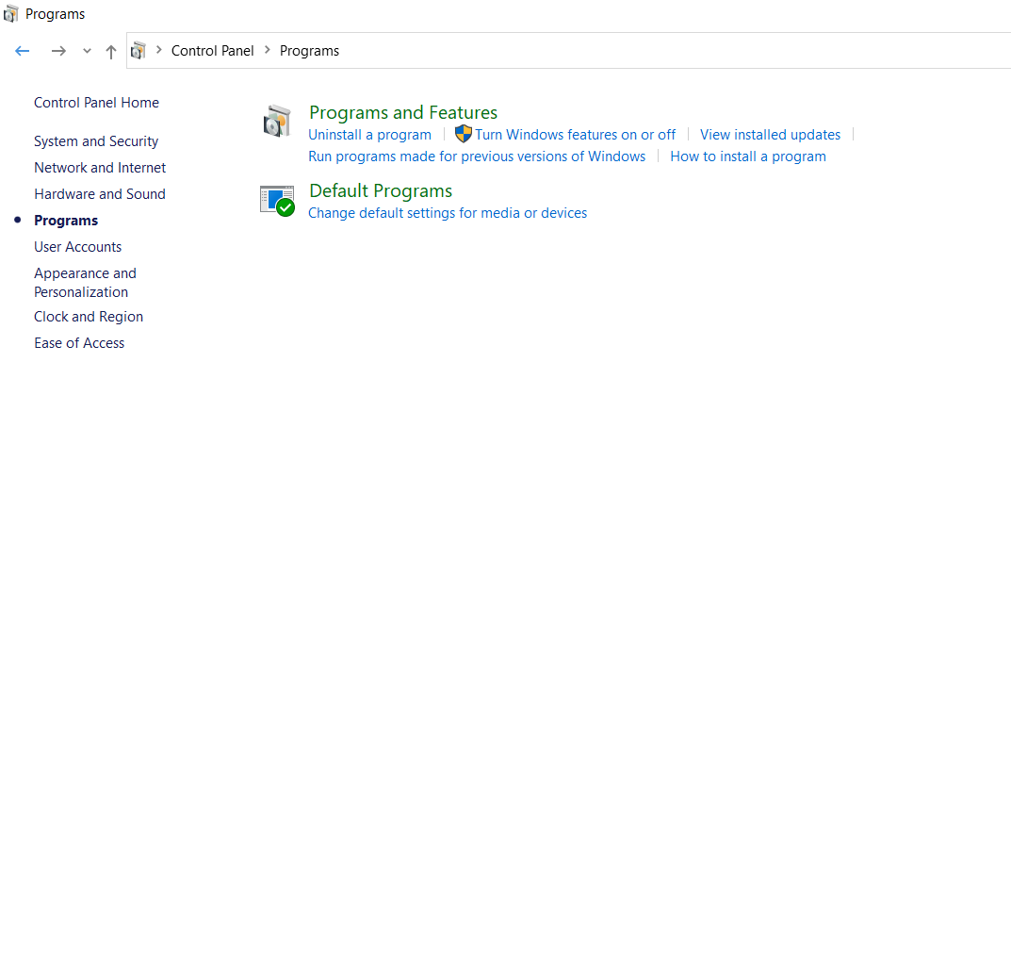

Figure 1: Programs and features

1. Tick for Virtual Machine Platform and Windows Subsystem for Linux -> OK

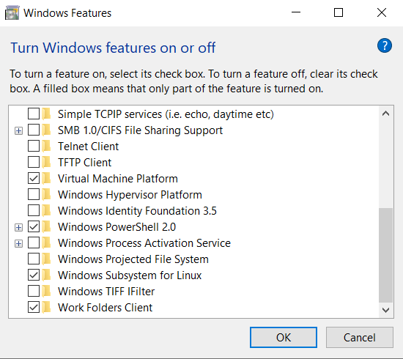

Figure 2: Turn Windows features ON or OFF

1. Restart the system at this stage by clicking on Restart now.

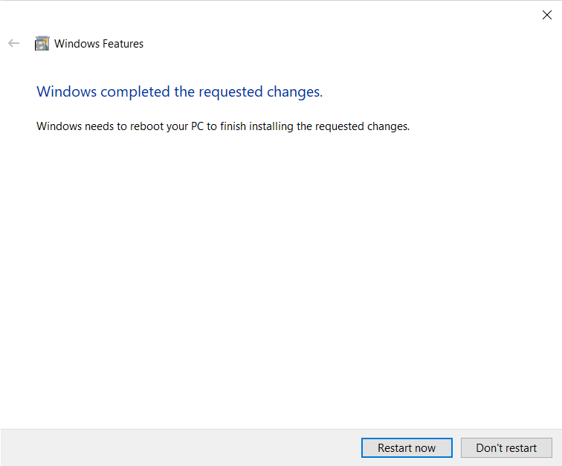

Figure 3: Restart the system

## Installing Linux

Install the latest version of Linux:

1. Menu tab -> Microsoft store -> In Search option type Ubuntu. Which will show the results for Ubuntu, Click on Get to download the latest version of Ubuntu.

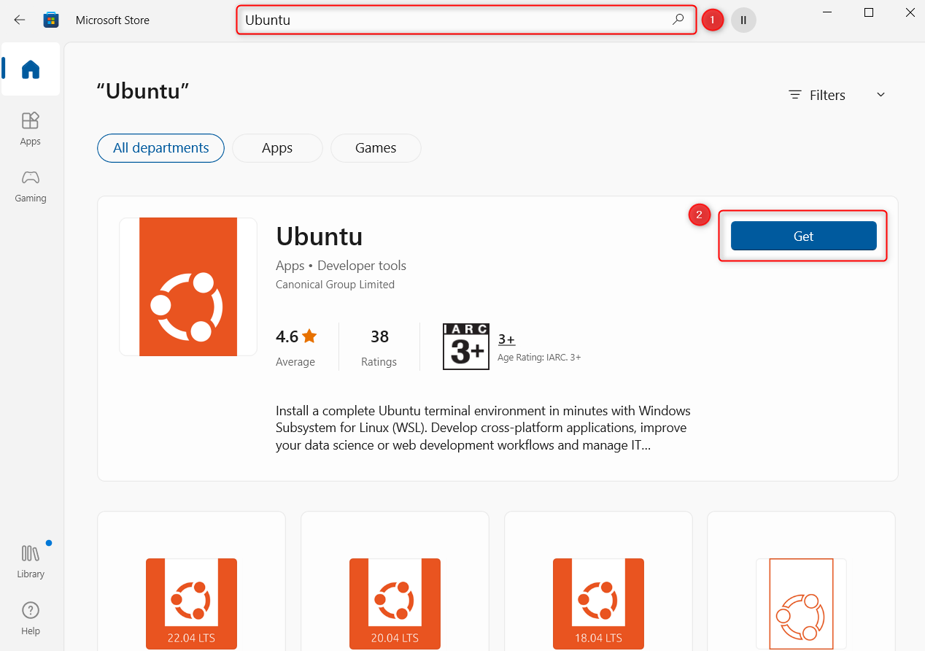

Figure 4: Open Microsoft store to install Ubuntu

1. Once the download is complete, open Ubuntu from the Menu tab and provide the following when prompted:
   1. Enter new UNIX username
   2. New password
   3. Retype new password

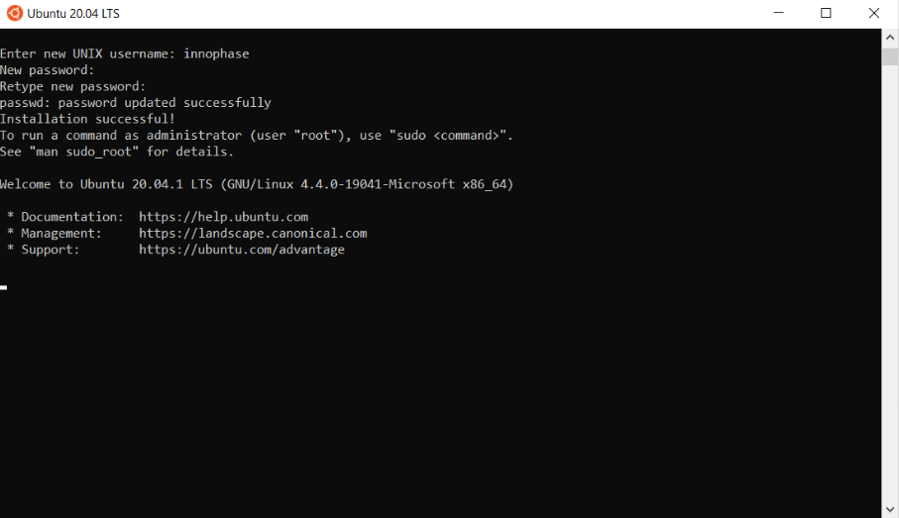

Figure 5: Username and password

1. This will open a terminal window in the directory in which commands can be typed.

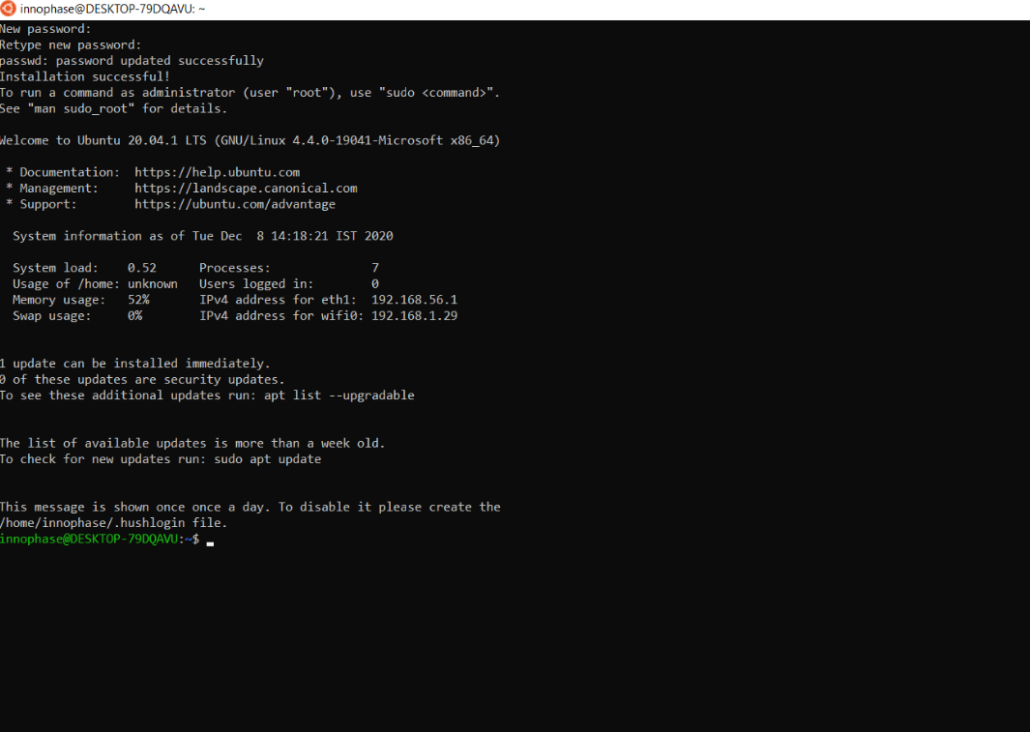

Figure 6: Terminal window

## Installing Necessary Packages

In the terminal window, execute the following commands entering the password which was set in Figure 6 when prompted.

|  |
| --- |
| sudo apt update |

|  |
| --- |
| sudo apt upgrade |

|  |
| --- |
| sudo apt-get update |

|  |
| --- |
| lsb_release -a |

Console output:

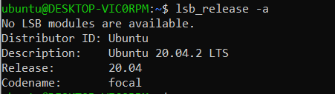

Figure 7: Installing necessary packages

## Accessing WSL Files from Windows

An important thing to note about WSL is that it hosts its own file system. The files you access within the WSL terminal are separate from your regular Windows file system. You can integrate your WSL files into the Windows File Explorer by changing to a particular directory in the WSL terminal and using the command:

|  |
| --- |
| explorer.exe |

## Install arm-none-eabi Toolchain

Install the GCC compiler packages.

|  |
| --- |
| sudo apt install gcc-arm-none-eabi |

|  |
| --- |
| arm-none-eabi-gcc --version |

Console output:

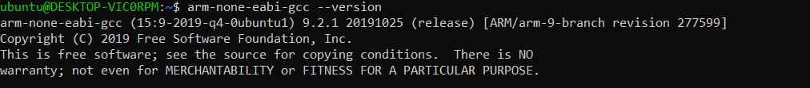

Figure 8: GCC compiler packages

## Install Python3 and packages

In any terminal window, execute the following commands to install Python3 and other Python packages that will be needed. Enter the password as prompted which was set in Figure 6.

|  |
| --- |
| sudo apt install python3 -y |

|  |
| --- |
| sudo apt install python3-pip -y |

|  |
| --- |
| python3 --version |

Console output:



Figure 9: Installing Python3 & packages

## Setting Execute Permissions for SDK Scripts

Compile the InnoPhase SDK

1. Open a terminal in the directory, for example: *sdk_x.y/apps*
2. Execute the make command. Use the ELFs generated in the application’s out folder.

|  |
| --- |
| make |

**Note**: User can also compile the required application, for example: *sdk_x.y/apps/helloworld/*.

1. By default, in the SDK package, the ELFs can be used from the application’s bin folder.

**Note**: x and y refer to the SDK release version. For example: sdk_2.5/doc.

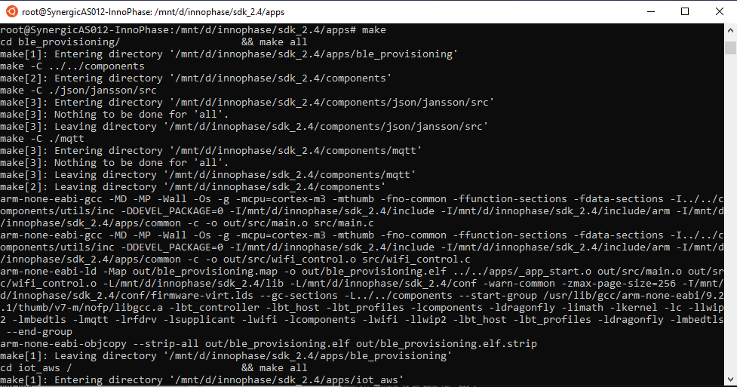

Figure 10: Compiling the InnoPhase SDK

## Programming Talaria TWO using Download Tool

Program the helloworld.elf (*sdk_x.y\apps\helloworld\bin*) onto Talaria TWO using the Download Tool:

1. Launch the Download tool provided with InnoPhase Talaria TWO SDK.
2. In the GUI window:
   1. Programming: Click on Clear Flash and ensure the output is as follows:

|  |
| --- |
| UART:NWWWWWAEBuild $Id: git-b664be2af $  app=gordon  flash: Gordon ready!  Y-BOOT 208ef13 2019-07-22 12:26:54 -0500 790da1-b-7  ROM yoda-h0-rom-16-0-gd5a8e586  FLASH:P |

* 1. Boot Target: Select the appropriate EVK from the drop-down
  2. ELF Input: Load the helloworld.elf by clicking on Select ELF File.
  3. Programming: Prog RAM or Prog Flash as per requirement.

Console output:

|  |
| --- |
| UART:NWWWWWAEBuild $Id: git-b664be2af $  app=gordon  flash: Gordon ready!  Y-BOOT 208ef13 2019-07-22 12:26:54 -0500 790da1-b-7  ROM yoda-h0-rom-16-0-gd5a8e586  FLASH:PNWWWAEBuild $Id: git-b664be2af $  Hello World |